The Jain International School, Kanpur
Class – II
SUBJECT | SUMMER HOLIDAY HOMEWORK
English | Do the given worksheets.  Roll No. 1 to 3 : Make a working model on naming words  Roll No. 4 to 6 : Make a chart on short forms  Roll No.7 to 9 : Make a chart on describing words
Hindi | Do the given worksheets.  Do the given worksheets.  Roll No. 1 to 3 : Make a working model on - ek=k,WA  Roll No. 4 to 6 : Make a chart on- LojA  Roll No.7 to 9 : Make a chart on- O;atuA
Mathematics | Do the given worksheets.  Roll No. 1 to 3 : Make a chart fractions  Roll No. 4 to 6 : Make a working model on measurement or shapes and patterns  Roll No.7 to 9 : Make a chart on money
Social Studies | Do the given worksheets.  Roll no. 1-4 Make a chart on the topic Be Safe  Roll no 5-9 Make a chart on different types of Food &clothes ( Lesson 7)
Science | Do the given worksheets.  Make a Model on any of the following topics:-  - Source of Light.  - Wind Mill. ( Working Model )  - Types of Food Groups/ Food Pyramid
Computer | (Roll No. 1 - 3 ) Make a Model on uses of computer in different area like school, shops, homes, hospitals, banks, railway station, airports and post offices.  (Roll No. 4 - 6) Make a Model on input devices and output devices.  (Roll No.7 – 9 ) Make a Model on additional part of computers.
General Knowledge | Roll No. 1 to 3 : Make a chart on Cartoon Characters  Roll No. 4 to 6 : Make a chart on Animals and their babies  Roll No.7 to 9 : Make a chart on Famous Monuments of India.  Write 10 current affairs in your G.K. notebook

The Jain International School , Kanpur
Subject: English
Holiday Homework Worksheet 1
Class – II
Name:- ___________________ Date: _______________
TOPIC : NOUN
Q. Pick out the Proper Nouns (P) and Common Nouns (C) from the following sentences:-
1. Ramesh is studying in his room. ________________________
2. The QutbMinar is a tall tower. ________________________
3. January is the first month of the year. ________________________
4. Singapore is a small country. ________________________
5. Lucknow is a city in Uttar Pradesh. ________________________
6. Prachi is packing her bag. ________________________
7. Who is the president of Sri Lanka? ________________________
8. Tarun makes good drawings. ________________________
9. The Red Fort is made of sandstone. ________________________
10. Is Piyush ready for school? ________________________
11. My uncle lives in Hong Kong. ________________________
12. Does Pooja like gulabjamuns? _______________________
Which letter of the alphabet wants to know the reasons all the time?

The Jain International School , Kanpur
Subject: Mathematics
Holiday Homework Worksheet 2
Class – II
Name:- ___________________ Date: _______________
TOPIC : GENDER
Q. Rewrite these sentences changing the Gender of the underlined words:-
1. Her sister is good at mathematics. ________________________
2. The landlord lives on the first floor. ________________________
3. What is the gender of a goose? ________________________
4. The bridegroom is related to me. ________________________
5. The wizard whispers the magic words. ________________________
6. The lion brings food for the cubs. ________________________
7. Sir is calling for you. ________________________
8. His son is in my class._____________________________
9. I am her niece. ________________________
10. The emperor is kind and generous. ________________________
11. The man is looking for you. ________________________
12. My grandmother makes tasty snacks. ________________________
A new English word is created every 98 minutes.

THE JAIN INTERNATIONAL SCHOOL
HOLIDAY HOME WORK
CLASS-2
Sheet No.1
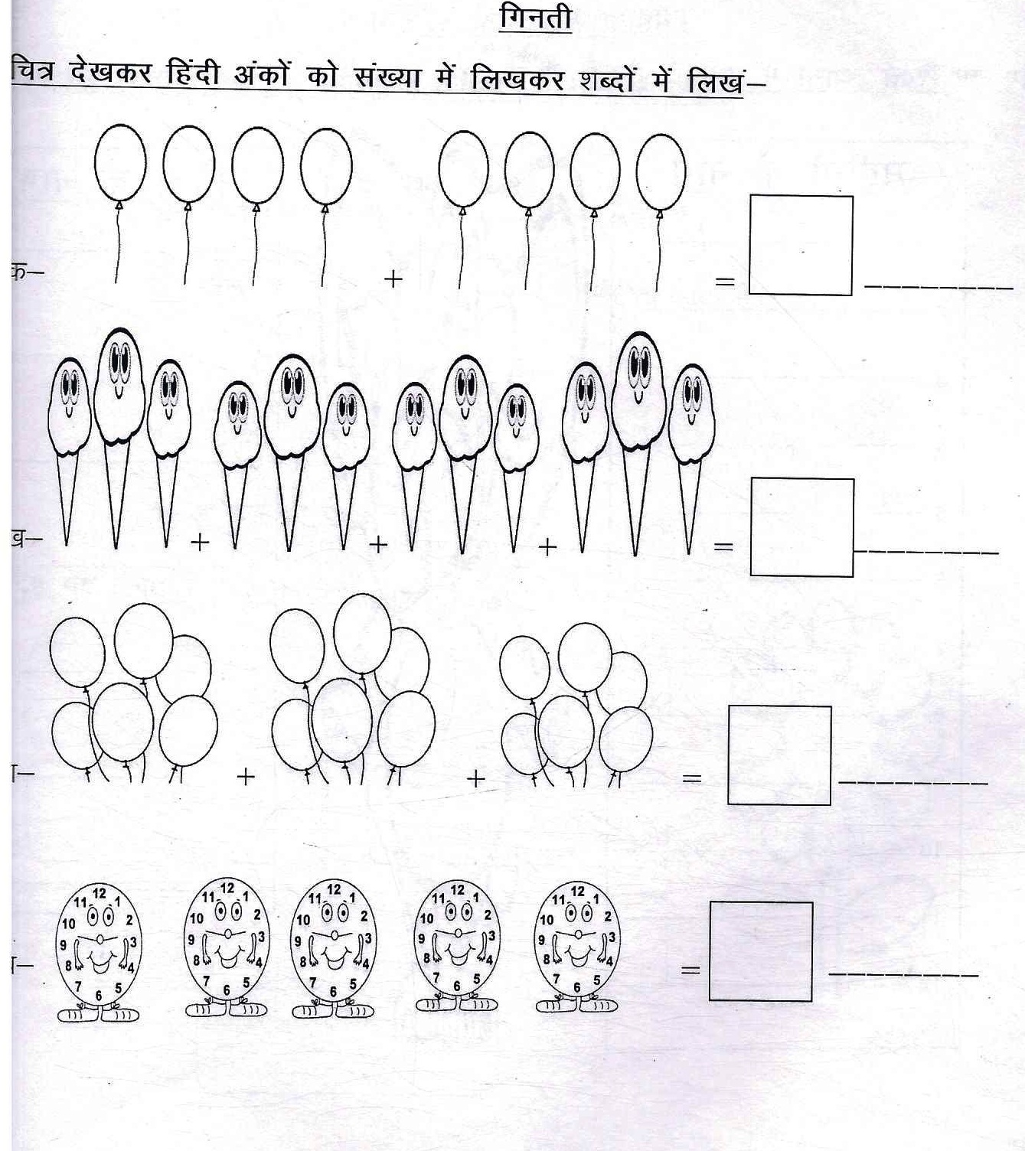
THE JAIN INTERNATIONAL SCHOOL
HOLIDAY HOME WORK
CLASS-2
Sheet No.2
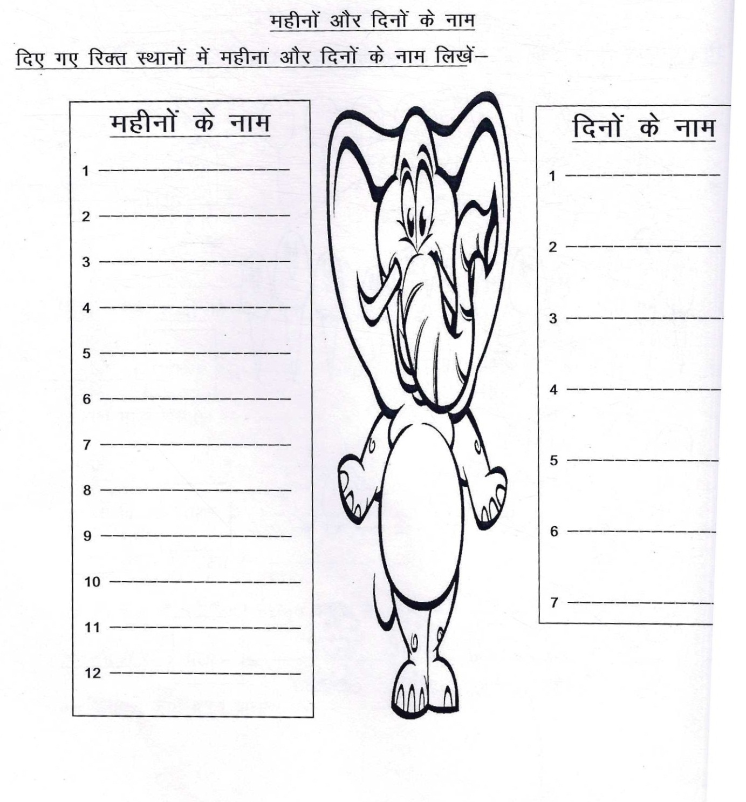

The Jain International School , Kanpur
Subject: Mathematics
Holiday Homework Worksheet 1
Class – II
Name:- ___________________ Date: _______________

TOPIC : Expanded Form

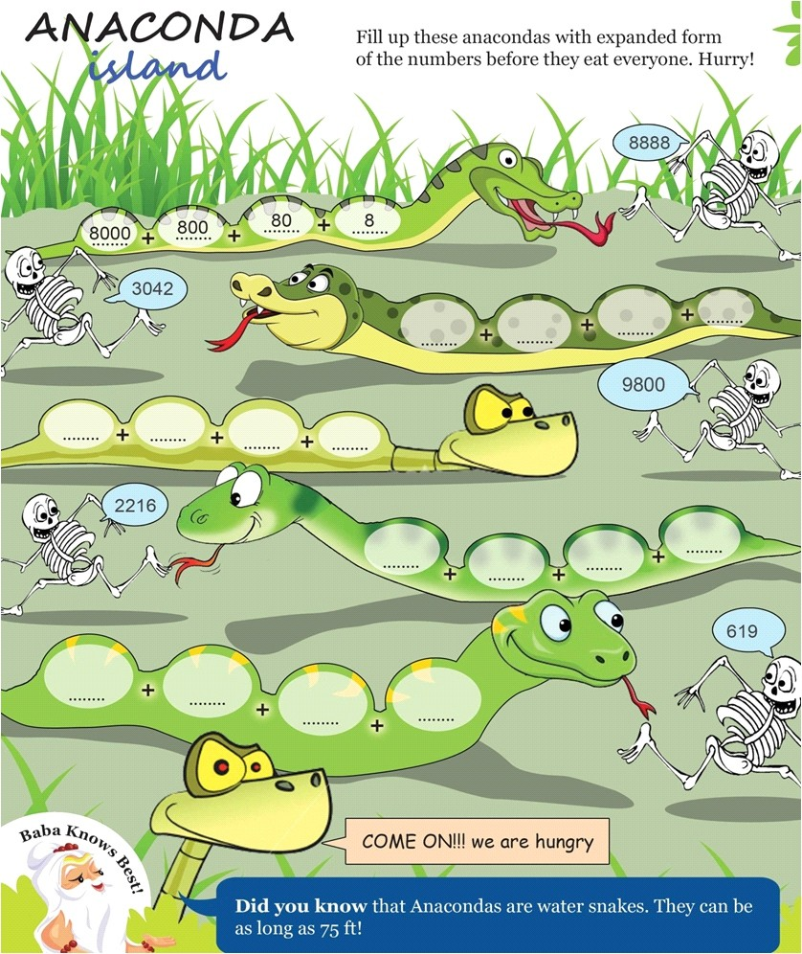
The Jain International School , Kanpur
Subject: Mathematics
Holiday Homework Worksheet 2
Class – II
Name:- ___________________ Date: _______________
TOPIC : Addition
Addition without carrying over:
- T O b) T O c) T O
2 3 4 3 5 3
+ 2 1 + 2 2 + 2 4
______ ______ ______

- T O e) T O f) T O
6 3 3 2 7 3
+ 2 1 + 2 2 + 2 3
_____ _ _____ ______

g) T O h) T O
2 5 4 8
+ 1 1 + 2 1

Nine is the highest single digit Arabic numeral.
______ ______
The Jain International School, Kanpur
Holiday Homework Worksheets 1
Subject: Science
Class – II
Name:______________________ Date : _____________

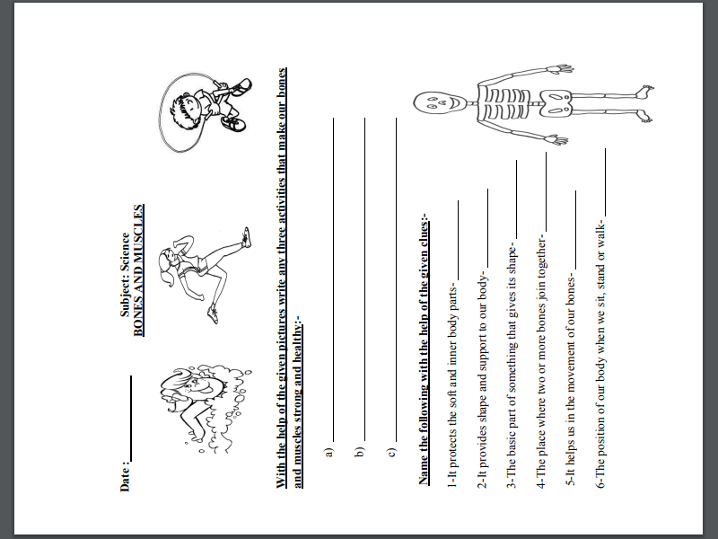

The Jain International School, Kanpur
Holiday Homework Worksheets 2
Subject: Science
Class – II
Name:______________________ Date : ____________
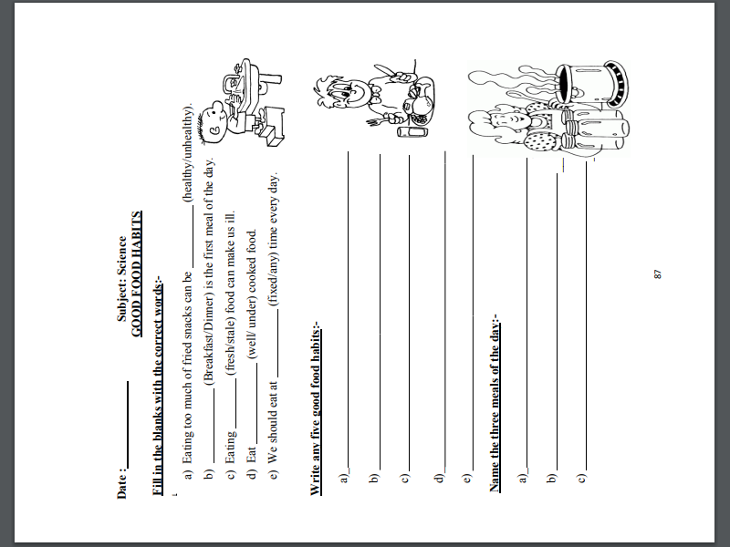

The Jain International School , Kanpur
Subject: Social Studies
Holiday Homework Worksheet 1
Class – II
Name:- ___________________ Date: _______________
___________________________________________________________________________________
FAMILY TIME
Match column A with the column B:-
Column A Column B

1. Grandparent (a) 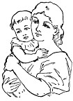

2. Mother (b)

3. Father (c)

4. Children (d) 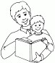

Look at the picture given below and write the names of types of families:-

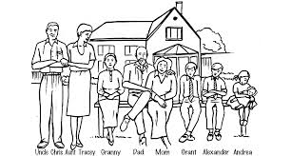

1.
The Jain International School , Kanpur
Subject: Social Studies
Holiday Homework Worksheet 2
Class – II
Name:- ___________________ Date: _______________
___________________________________________________________________________________
SCHOOL IS FUN

Fill in the blanks with the correct option:-

1. | We learn to __________ at school.
 | (a) read ( ) |  | (b) sleep ( | ) | (c) eat ( | )
2. | Who drives your school bus?
 | (a) teacher ( | ) | (b) librarian ( | ) | (c) driver ( | )
3. | Who helps us to learn at school?
 | (a) doctor ( | ) | (b) teacher ( | ) | (c) driver ( | )

4. Who looks after the plants at school?

(a) gardener ( ) (b) librarian ( ) (c) receptionist ( )
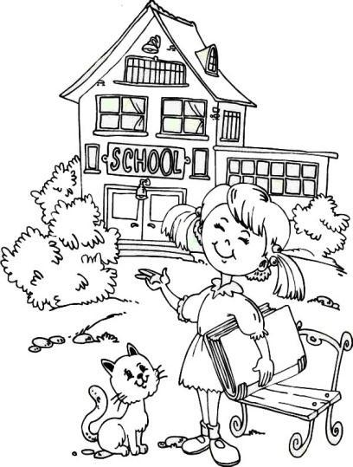

Name the following places in a school:-

playground | staffroom | music room
library | classroom | computer room

- The room for the teachers-_____________________

- The room which has many books-_____________________

- The place where the children play -___________________

- The room where the children read and write -_____________________

- The room where the children learn to sing-_____________________

- The room where the children learn how to use computer -_____________________

